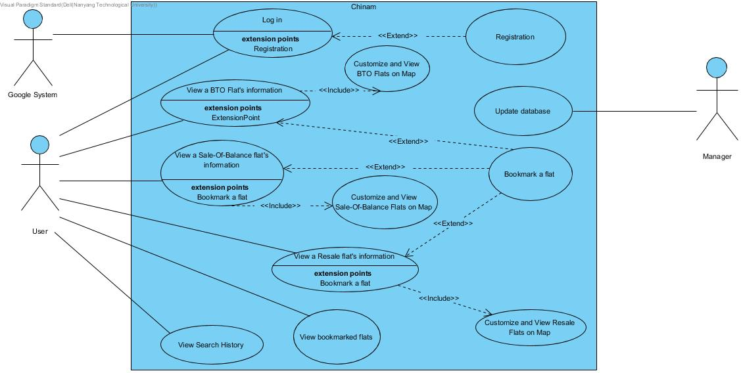

**Use Case**

|  |  |  |  |
| --- | --- | --- | --- |
| Use Case ID: | UC-01 | | |
| Use Case Name: | Registration | | |
| Created By: | Chinam | Last Updated By: | Chinam |
| Date Created: | 05/02/2019 | Date Last Updated: | 07/02/2019 |

|  |  |
| --- | --- |
| Actor: | User, Google system |
| Description: | Allow users that do not have an account to create their accounts |
| Preconditions: | 1. The user must not have an account before 2. The user must not be logged in |
| Postconditions: | The user has created an account |
| Priority: | Nil |
| Frequency of Use: | Nil |
| Flow of Events: | 1. The user taps button “sign up with google” 2. The system will bring user to google’s registration site to register a new acccount. 3. The user will follow google’s registration procedure to register for an account. 4. Google will bring the user back to the login page after user is done with registration |
| Alternative Flows: | Nil |
| Exceptions: | Nil |
| Includes: | Nil |
| Special Requirements: | Nil |
| Assumptions: | Nil |
| Notes and Issues: | Nil |

|  |  |  |  |
| --- | --- | --- | --- |
| Use Case ID: | UC-02 | | |
| Use Case Name: | Login | | |
| Created By: | Chinam | Last Updated By: | Chinam |
| Date Created: | 05/02/2019 | Date Last Updated: | 07/02/2019 |

|  |  |
| --- | --- |
| Actor: | User, Google system |
| Description: | Allow users to login to their account |
| Preconditions: | The user must not be logged in |
| Postconditions: | The user is logged in |
| Priority: | Nil |
| Frequency of Use: | Depends on users |
| Flow of Events: | 1. The user enters the login page 2. The user taps “sign in with google” button 3. The system will bring user to google’s login site 4. The user will follow google’s sign-in procedure to complete login steps 5. The system logs the user in 6. The system display the first main page of the application by default |
| Alternative Flows: | AF-S0: User does not have an account   1. User creates an account using extended use case UC-01 (Registration) 2. Return to step 1 |
| Exceptions: | Nil |
| Includes: | Nil |
| Special Requirements: | Nil |
| Assumptions: | Internet connection is enabled in the device |
| Notes and Issues: | Nil |

|  |  |  |  |
| --- | --- | --- | --- |
| Use Case ID: | UC-03 | | |
| Use Case Name: | Customize and view BTO flats on map | | |
| Created By: | Chinam | Last Updated By: | Chinam |
| Date Created: | 05/02/2019 | Date Last Updated: | 07/02/2019 |

|  |  |
| --- | --- |
| Actor: | User |
| Description: | Allow the user to customize the conditions for BTO flats that they want to search for and view them on map. |
| Preconditions: | The user must be logged in |
| Postconditions: | The user successfully customizes the conditions of BTO flats that they want to search and view them on map |
| Priority: | Nil |
| Frequency of Use: | Depends on users |
| Flow of Events: | 1. The User chooses the Build-To-Order (BTO) category under the public housing options. 2. The system directs the user to BTO page 3. The user must choose between two options: “Upcoming launches” and “Past launches”. 4. The User must choose the type of flat from a dropdown list (e.g 2-room, 3-room, …) 5. The user may choose the selling price range 6. The user taps “next” button 7. The system directs user to the region page 8. The user selects the region 9. The system applies the customization to filter the flats that match the conditions in the selected regions 10. The System displays the locations of those flats on the region map. |
| Alternative Flows: | AF-S3: The user chooses Upcoming launches   1. The system directs user to the upcoming launches page |
| Exceptions: | Nil |
| Includes: | Nil |
| Special Requirements: | Nil |
| Assumptions: | Internet connection is enabled in the device |
| Notes and Issues: | Nil |

|  |  |  |  |
| --- | --- | --- | --- |
| Use Case ID: | UC-04 | | |
| Use Case Name: | Customize and view Sale-Of-Balance flats on map | | |
| Created By: | Chinam | Last Updated By: | Chinam |
| Date Created: | 05/02/2019 | Date Last Updated: | 07/02/2019 |

|  |  |
| --- | --- |
| Actor: | User |
| Description: | Allow the user to customize the conditions for Sale-Of-Balance (SOB) flats that they want to search for and view them on map. |
| Preconditions: | The user must be logged in |
| Postconditions: | The user successfully customizes the conditions of Sale-Of-Balance flats that they want to search and view them on map |
| Priority: | Nil |
| Frequency of Use: | Depends on users |
| Flow of Events: | 1. The User chooses the Sale-Of-Balance (SBF) flats category under the public housing options. 2. The system directs the user to SBF page 3. The User must choose the type of flat from a dropdown list (e.g 2-room, 3-room, …) 4. The user may choose the flat supply range 5. The user may choose the ethnic group 6. The user may choose different ethnic quota range 7. The user taps “next” button 8. The system directs user to the region page 9. The user selects the region 10. The system applies the customization to filter the flats that match the conditions in the selected regions 11. The System displays the locations of those flats on the region map. |
| Alternative Flows: | Nil |
| Exceptions: | Nil |
| Includes: | Nil |
| Special Requirements: | Nil |
| Assumptions: | Internet connection is enabled in the device |
| Notes and Issues: | Nil |

|  |  |  |  |
| --- | --- | --- | --- |
| Use Case ID: | UC-05 | | |
| Use Case Name: | Customize and view resale flats on map | | |
| Created By: | Chinam | Last Updated By: | Chinam |
| Date Created: | 05/02/2019 | Date Last Updated: | 07/02/2019 |

|  |  |
| --- | --- |
| Actor: | User |
| Description: | Allow the user to customize the conditions for Resale flats that they want to search for and view them on map. |
| Preconditions: | The user must be logged in |
| Postconditions: | The user successfully customizes the conditions of resale flats that they want to search and view them on map |
| Priority: | Nil |
| Frequency of Use: | Depends on users |
| Flow of Events: | 1. The User chooses the resale flat category under the public housing options. 2. The system directs the user to Resale page 3. The User must choose the type of flat from a dropdown list (e.g 2-room, 3-room, …) 4. The User may choose the price range 5. The user may choose the remaining lease range 6. The User may choose the storey range 7. The User may choose the floor area range 8. The user taps “next” button 9. The system directs user to the region page 10. The user selects the region 11. The system applies the customization to filter the flats that match the conditions in the selected regions 12. The System displays the locations of those flats on the region map. |
| Alternative Flows: | Nil |
| Exceptions: | Nil |
| Includes: | Nil |
| Special Requirements: | The api is up and running |
| Assumptions: | Internet connection is enabled in the device |
| Notes and Issues: | Nil |

|  |  |  |  |
| --- | --- | --- | --- |
| Use Case ID: | UC-06 | | |
| Use Case Name: | View a BTO flat’s information | | |
| Created By: | Chinam | Last Updated By: | Chinam |
| Date Created: | 05/02/2019 | Date Last Updated: | 07/02/2019 |

|  |  |
| --- | --- |
| Actor: | User |
| Description: | Allow users to view a specific BTO flat’s information |
| Preconditions: | The user must be logged in |
| Postconditions: | The user can view information about certain BTO flat |
| Priority: | Nil |
| Frequency of Use: | Depend on users |
| Flow of Events: | 1. The user views the BTO flats that they want the application to filter out using the included use case UC-03 (Customize and view BTO flats on map) 2. The user taps a specific flat location on the map 3. The system direct the user to the result page 4. The system displays information about the chosen flat 5. The user may choose to bookmark the flat using the extended use case UC-09 (Bookmark a flat) |
| Alternative Flows: | Nil |
| Exceptions: | Nil |
| Includes: | UC-03 Customize and view BTO flats on map |
| Special Requirements: | Nil |
| Assumptions: | Internet connection is enabled in the device |
| Notes and Issues: | Nil |

|  |  |  |  |
| --- | --- | --- | --- |
| Use Case ID: | UC-07 | | |
| Use Case Name: | View a Sale-Of-Balance flat’s information | | |
| Created By: | Chinam | Last Updated By: | Chinam |
| Date Created: | 05/02/2019 | Date Last Updated: | 07/02/2019 |

|  |  |
| --- | --- |
| Actor: | User |
| Description: | Allow users to view a specific Sale-Of-Balance flat’s information |
| Preconditions: | The user must be logged in |
| Postconditions: | The user can view information about certain Sale-Of-Balance flat |
| Priority: | Nil |
| Frequency of Use: | Depend on users |
| Flow of Events: | 1. The user views the Sale-Of-Balance flats that they want the application to filter out using the included use case UC-04 (Customize and view Sale-Of-Balance flats on map) 2. The user taps a specific flat location on the map 3. The system direct the user to the result page 4. The system displays information about the chosen flat 5. The user may choose to bookmark the flat using the extended use case UC-09 (Bookmark a flat) |
| Alternative Flows: | Nil |
| Exceptions: | Nil |
| Includes: | UC-04 Customize and view Sale-Of-Balance flats on map |
| Special Requirements: | Nil |
| Assumptions: | Internet connection is enabled in the device |
| Notes and Issues: | Nil |

|  |  |  |  |
| --- | --- | --- | --- |
| Use Case ID: | UC-08 | | |
| Use Case Name: | View a Resale flat’s information | | |
| Created By: | Chinam | Last Updated By: | Chinam |
| Date Created: | 05/02/2019 | Date Last Updated: | 07/02/2019 |

|  |  |
| --- | --- |
| Actor: | User |
| Description: | Allow users to view a specific Resale flat’s information |
| Preconditions: | The user must be logged in |
| Postconditions: | The user can view information about certain Resale flat |
| Priority: | Nil |
| Frequency of Use: | Depend on users |
| Flow of Events: | 1. The user views the flats that they want the application to filter out using the included use case UC-05 (Customize and view Resale flats on map) 2. The user taps a specific flat location on the map 3. The system direct the user to the result page 4. The system displays information about the chosen flat 5. The user may choose to bookmark the flat using the extended use case UC-09 (Bookmark a flat) |
| Alternative Flows: | Nil |
| Exceptions: | Nil |
| Includes: | UC-05 Customize and view Resale flats on map |
| Special Requirements: | Nil |
| Assumptions: | Internet connection is enabled in the device |
| Notes and Issues: | Nil |

|  |  |  |  |
| --- | --- | --- | --- |
| Use Case ID: | UC-09 | | |
| Use Case Name: | Bookmark a flat | | |
| Created By: | Chinam | Last Updated By: | Chinam |
| Date Created: | 05/02/2019 | Date Last Updated: | 07/02/2019 |

|  |  |
| --- | --- |
| Actor: | User |
| Description: | Allow users to mark any flat’s information for future consideration |
| Preconditions: | The user is viewing a specific flat information |
| Postconditions: | The information of chosen flat is marked and save into the app memory |
| Priority: | Nil |
| Frequency of Use: | Depend on users |
| Flow of Events: | 1. The user tap bookmark icon in the information page 2. The system saves the chosen flat information into the user account |
| Alternative Flows: | Nil |
| Exceptions: | Nil |
| Includes: | Nil |
| Special Requirements: | Nil |
| Assumptions: | Internet connection is enabled in the device |
| Notes and Issues: | Nil |

|  |  |  |  |
| --- | --- | --- | --- |
| Use Case ID: | UC-10 | | |
| Use Case Name: | Update database | | |
| Created By: | Chinam | Last Updated By: | Chinam |
| Date Created: | 05/02/2019 | Date Last Updated: | 07/02/2019 |

|  |  |
| --- | --- |
| Actor: | System manager |
| Description: | Allow manager to update the database manually |
| Preconditions: | Nil |
| Postconditions: | Database is updated |
| Priority: | Nil |
| Frequency of Use: | Once a month |
| Flow of Events: | 1. The manager manually crawls the latest information about flat from the government website 2. The manager upload and replace the database with the newest information |
| Alternative Flows: | Nil |
| Exceptions: | Nil |
| Includes: | Nil |
| Special Requirements: | Nil |
| Assumptions: | Internet connection is enabled in the device |
| Notes and Issues: | Nil |

|  |  |  |  |
| --- | --- | --- | --- |
| Use Case ID: | UC-11 | | |
| Use Case Name: | View bookmarked flats | | |
| Created By: | Chinam | Last Updated By: | Chinam |
| Date Created: | 05/02/2019 | Date Last Updated: | 07/02/2019 |

|  |  |
| --- | --- |
| Actor: | User |
| Description: | Allow the user to view the certain flat in the bookmarked flats list |
| Preconditions: | The user must be logged in |
| Postconditions: | The list of bookmarked flats is displayed |
| Priority: | Nil |
| Frequency of Use: | Depend on users |
| Flow of Events: | 1. The user tap bookmark icon on the main page 2. The system displays a list of bookmarked flats 3. The user chooses the flat they they want to view 4. The system display that flat information |
| Alternative Flows: | Nil |
| Exceptions: | Nil |
| Includes: | Nil |
| Special Requirements: | Nil |
| Assumptions: | Internet connection is enabled in the device |
| Notes and Issues: | Nil |